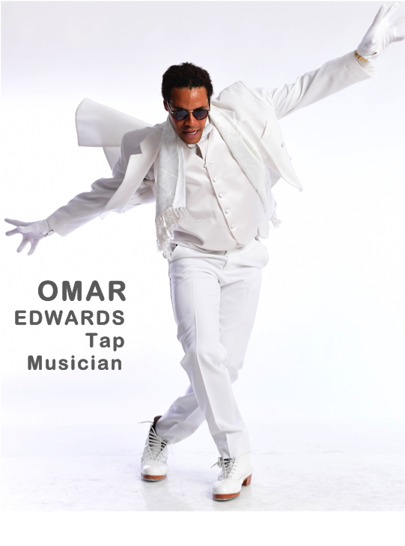

**Omar Edwards/ Tap Artist**

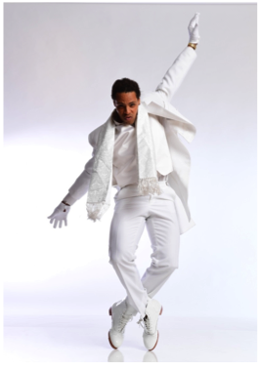**Omar Edwards**, award-winning tap dancer/entertainer/musician, has been in love with tap since he was twelve years old. Born in Brooklyn, Omar’s dancing has been shaped by more than twenty-three years of experience and formal training with masters including Henry Letang, Jimmy Slyde, Marie Brooks and his legendary cousin, Savion Glover. Omar has also trained under the tutelage of the great musician/songwriter Olu Dara.

Omar first earned national acclaim when he and then tap partner Daniel B. Wooten, Jr. were grand prize-winners on the famed T.V. show “Star Search.” From there, Omar embarked on a tap dance career that now spans the worlds of music, dance, television, theatre, and film. In 1998, Omar, along with four musicians, recorded “Tap Dancin’ is Music,” making Omar the first of his generation to feature the tap dancer as the bandleader and lead instrumentalist.

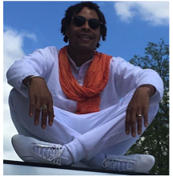Omar’s journey includes performances in a variety of venues, including on Broadway, where he was a featured dancer in *Bring in 'da Noise, Bring in 'da Funk* in 1996. In addition, he has performed for President Barrak Obama at the White House with Savion Glover, and on the Ellen DeGeneres Show. Most recently, Omar performed the role of the Tap Griot in *Fly*, Trey Ellis and Ricardo Khan’s award-winning play about the famed Tuskegee Airmen of WWII at the Tony Award® winning Crossroads Theatre Company.

Omar has a unique ability to transfer his passion for the arts through the rhythm of his tap shoes. He has shared his talent with many people around the world, including in France, Japan, Germany and the Philippines. As Omar continues on the very personal journey of being a great musician with his feet, he is also striving to bring together all of the elements in a visual experience that transcends their separateness. As he states, “It's complicated.”

**CAREER HIGHIGHTS**

***TAP DANICN’ IS MUSIC***

~Hub City Theatre Festival /Crossroads Theatre Company, New Brunswick, NJ

***FLY (Encore Tour)***

~Sarasota Stage, Sarasota, FL, Pasadena Playhouse , CA , New Victory Theatre NYC, (03/2016) Crossroads Theatre Company, NJ

***TAP ALL-STARS***

**~** Duke Theater NYC (Solo Performer)

***BLACK AND BLUE***

~Broadway

~International tour

***BRING IN THE NOISE, BRING IN THE FUNK,***

~International Tour

***CAMP*** /**Musical Movie** NYC

~Featured Performer~

**Alicia Keys Live at the Hollywood Bowl**

~Featured performer~

**The Question** with Common & Mos Def

**Sandman/** Legendary TV Show with the same name

~Featured performer~

**Harlem Nights** (Live TV/Japan)

**New York City’s Tap Extravaganza**

~Featured performer~

**Savion Glover’s NYOT (Not your Ordinary Tapper**

~Company Member~